Όνομα: _______________________________________________ Τάξη: _____
Ημερομηνία: _________________________________ Ημέρα: ____________

Ουσιαστικά
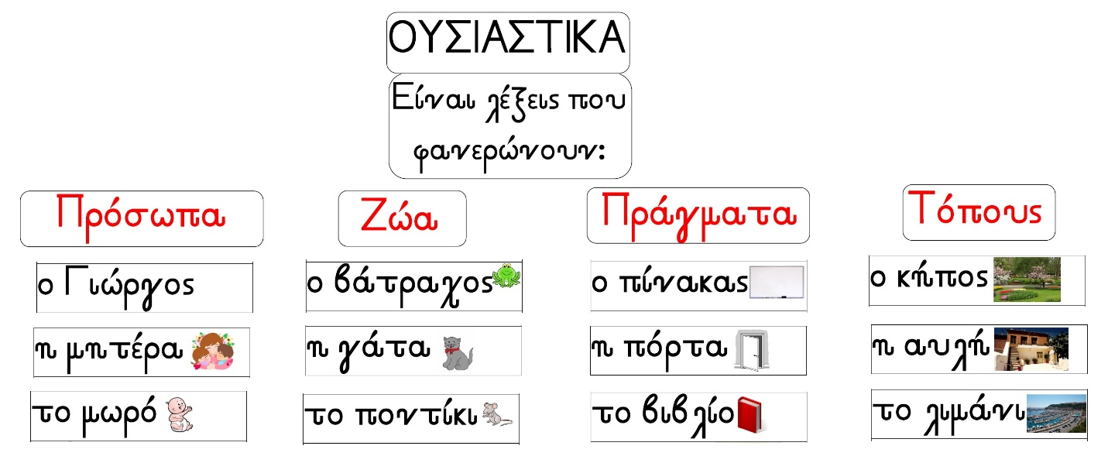
Να γράψεις όσα περισσότερα ουσιαστικά γνωρίζεις. Τα βίντεο θα σε βοηθήσουν.
____________________________________________________________________________________
____________________________________________________________________________________
____________________________________________________________________________________
____________________________________________________________________________________
____________________________________________________________________________________
____________________________________________________________________________________
____________________________________________________________________________________
____________________________________________________________________________________
____________________________________________________________________________________
____________________________________________________________________________________
____________________________________________________________________________________
____________________________________________________________________________________

